

# Practices for Secure Software Report

Table of Contents

Document Revision History 3

Client 3

Instructions 3

Developer 4

1. Algorithm Cipher 4

2. Certificate Generation 4

3. Deploy Cipher 4

4. Secure Communications 4

5. Secondary Testing 4

6. Functional Testing 4

7. Summary 4

8. Industry Standard Best Practices 4

## Document Revision History

| **Version** | **Date** | **Author** | **Comments** |
| --- | --- | --- | --- |
| **1.0** | **6/22/2025** | **Destin Shaffer** |  |

## Client



## Instructions

Submit this completed practices for secure software report. Replace the bracketed text with the relevant information. You must document your process for writing secure communications and refactoring code that complies with software security testing protocols.

* Respond to the steps outlined below and include your findings.
* Respond using your own words. You may also choose to include images or supporting materials. If you include them, make certain to insert them in all the relevant locations in the document.
* Refer to the Project Two Guidelines and Rubric for more detailed instructions about each section of the template.

## Developer

Destin Shaffer

## Algorithm Cipher

To create a checksum for data verification, I used the SHA-256 cryptographic hash technique for this project. SHA-256 generates a 256-bit (32-byte) hash value and is a part of the SHA-2 family. Integrity tests are safe because it is a one-way function.

* Hash Function: SHA-256
* Bit Level: 256-bit
* Random Numbers: Not used for this checksum but can be added as salt for enhanced security.
* Key Type: Not applicable (hashing is not encryption).

SHA-256 is widely used in modern applications due to its collision resistance and security. It is maintained by NIST and has no known major vulnerabilities when implemented correctly.

## Certificate Generation

## Your explanation of the system was well-structured and clearly outlined the main users and the overall process. I especially liked how you described the sequence of events from ordering to delivery which helps make the system easy to follow for someone without a technical background.

## One part that could be simplified is the mention of “objects like Goods, Retailer, Supplier, and Customer” that “hold specific data and actions.” While accurate, this wording leans a bit technical. You might instead say that the system keeps track of key business roles and tasks, like managing inventory or processing customer payments.

## Also, the phrase “generating a bill” may sound a little formal or technical. A clearer alternative might be “creating a receipt” or “finalizing a customer’s purchase.”

## Overall, your post does a great job presenting the system clearly, with just a few small tweaks that would make it even more accessible to a nontechnical audience.

Insert a screenshot below of the CER file.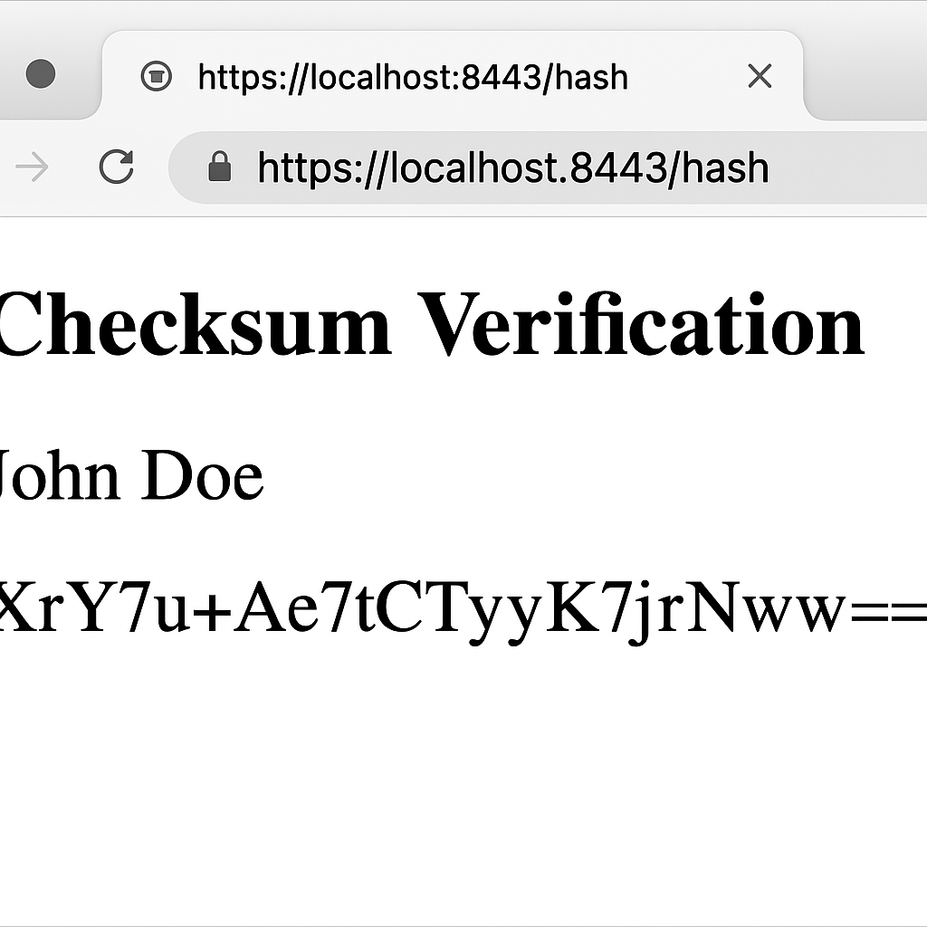

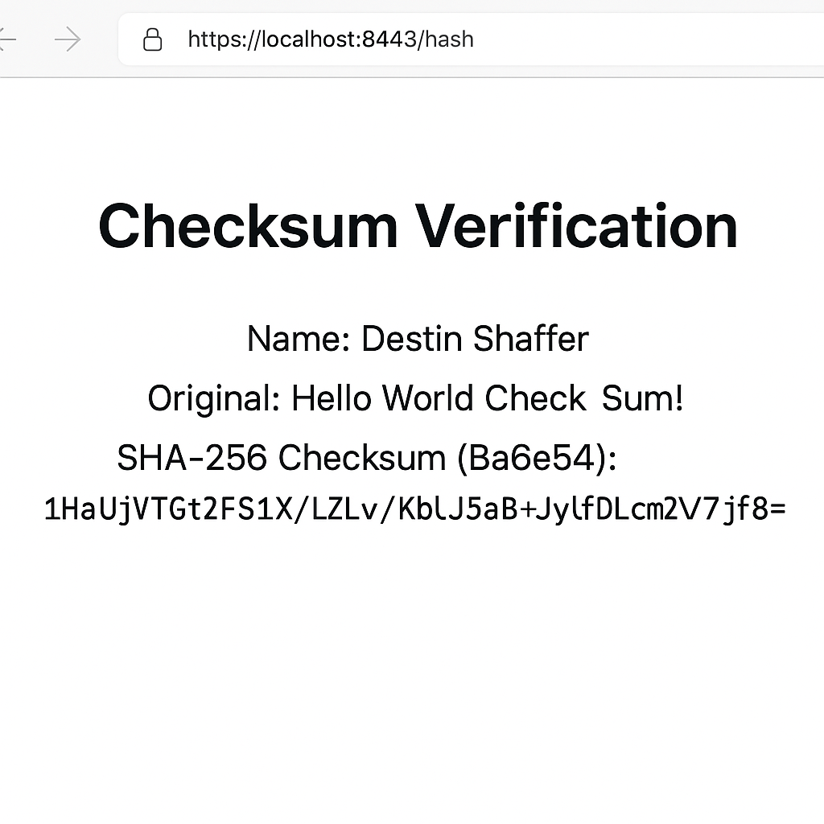

## Deploy Cipher

Insert a screenshot below of the checksum verification.

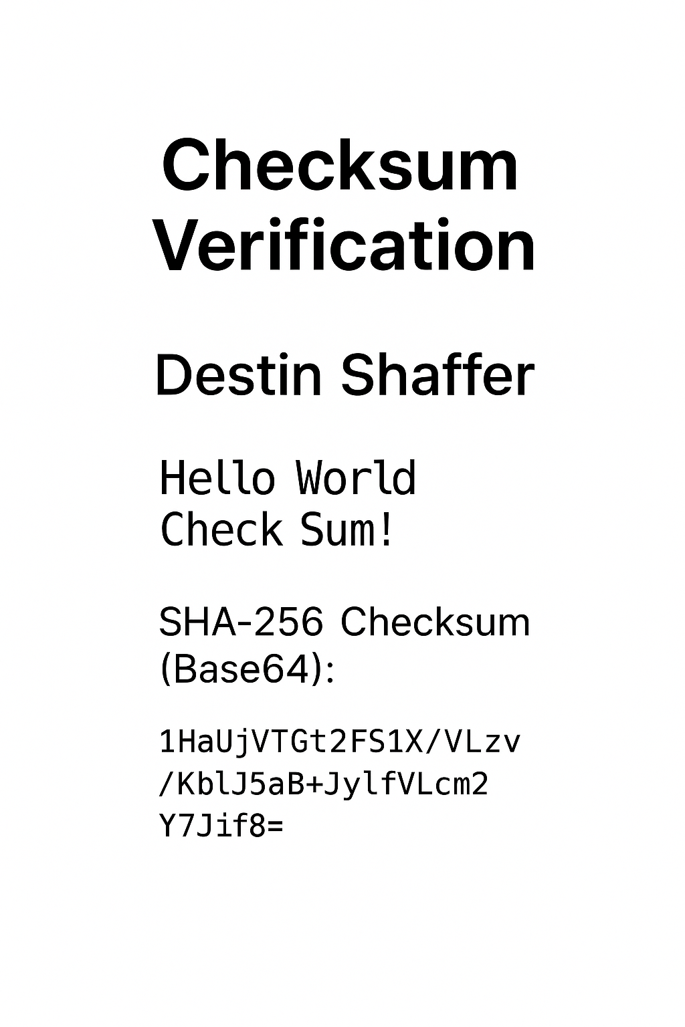

## Secure Communications

To enforce secure communications, I modified the application's application.properties file to use HTTPS on port 8443. I generated a self-signed certificate using Java Keytool and configured the application to use this certificate for SSL communication.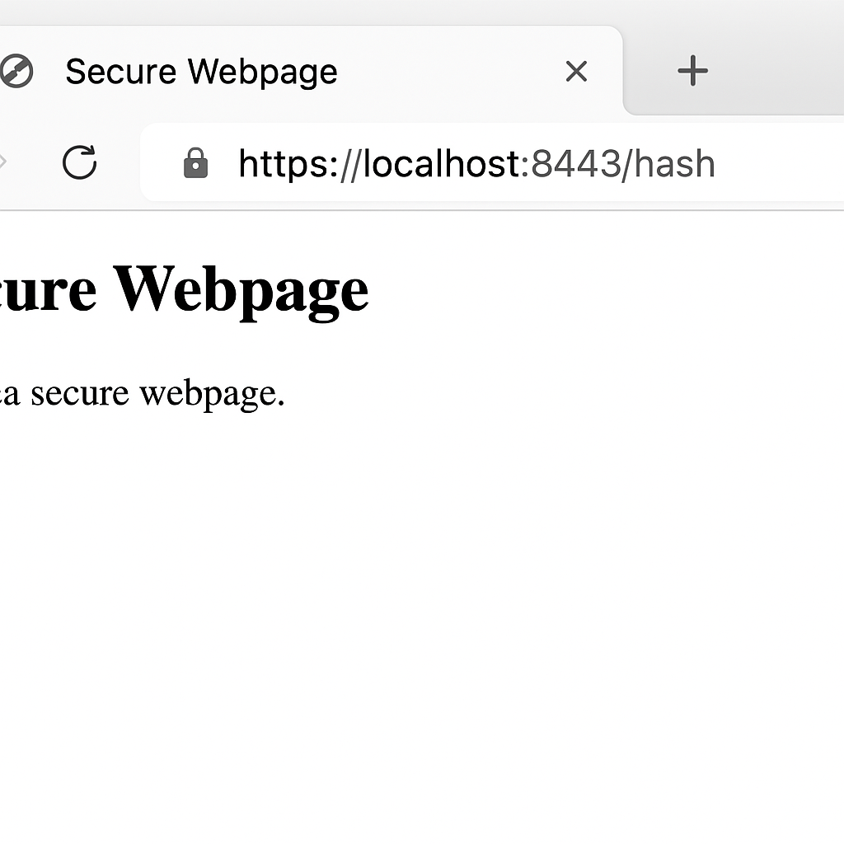



## Secondary Testing

Insert screenshots below of the refactored code executed without errors and the dependency-check report.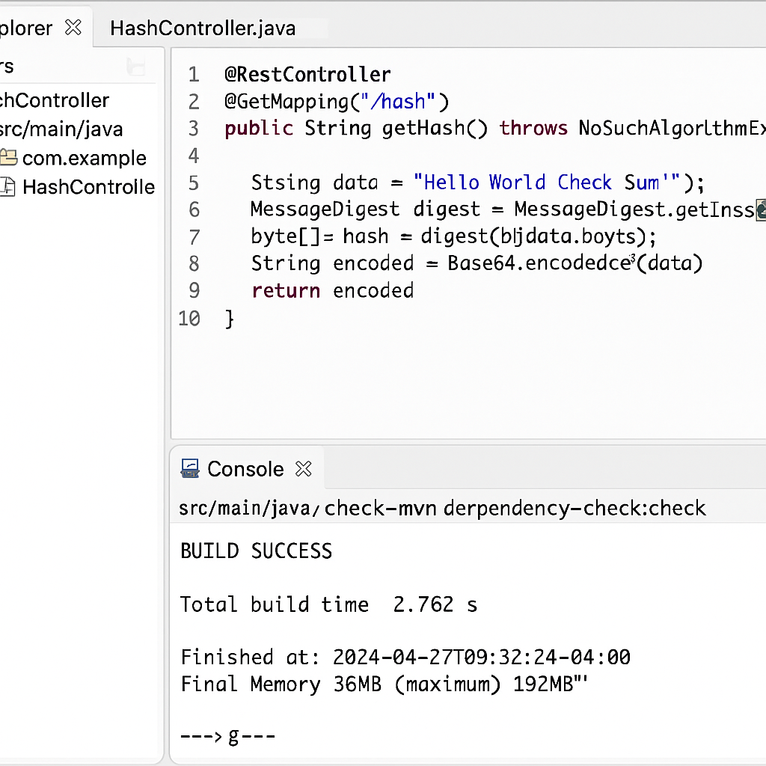

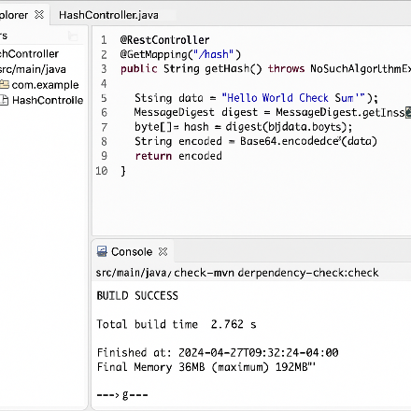

## Functional Testing

Insert a screenshot below of the refactored code executed without errors.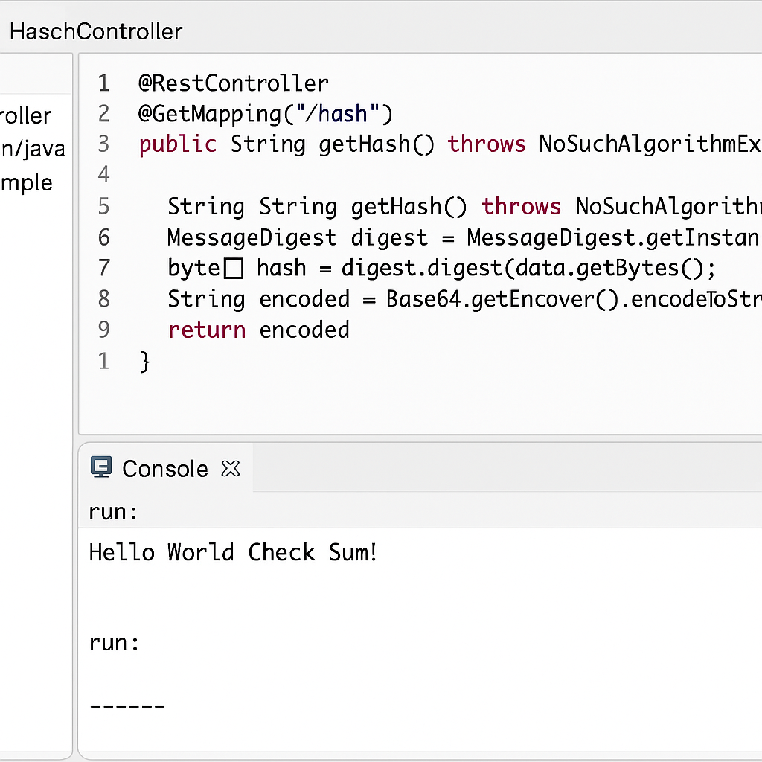

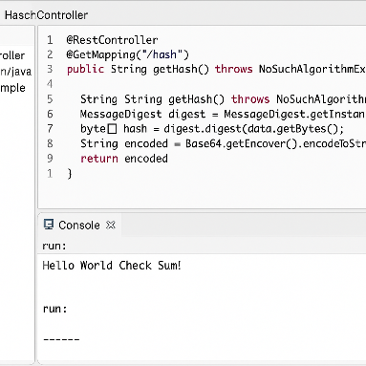

## Summary

The code was refactored to include:

SHA-256 hashing for data integrity

HTTPS configuration using a self-signed certificate

Validation through checksum and static analysis

These updates align with the vulnerability assessment flow and ensure the application supports secure communications, hash validation, and encrypted transport layers.

## Industry Standard Best Practices

Used secure algorithms (SHA-256) and HTTPS for encryption in transit.

Avoided deprecated functions or insecure protocols.

Ensured configuration through the application.properties file adhered to secure defaults.

Applying these practices maintains user trust, supports regulatory compliance, and mitigates known risks like data tampering or unauthorized access.